
Capital University
Faculty of Computer & Information Sciences
SOFTWARE REQUIREMENTS SPECIFICATION
IEEE 830 Standard
Subscription Box Platform
CS251 — Software Engineering

Course | CS251 — Software Engineering
Team Members | Moaaz Hassan | Hazem Ahmed | Marwan Ibrahim | Mostafa Mattar | Youssef Hany | Hossam Mohy
Supervisor | Dr Amr S. Ghoniem
Date | Spring 2026
Version | 1.0

1. Introduction

1.1 Purpose of This Document
This Software Requirements Specification (SRS) defines the functional and non-functional requirements for the Subscription Box Platform developed as part of the CS251 Software Engineering course. It follows the IEEE 830 standard and serves as the authoritative reference for system design, development, testing, and acceptance phases.
This document is intended for: project team members, course supervisors, and stakeholders responsible for evaluating and validating the system.

1.2 Project Scope
The Subscription Box Platform is a web-based e-commerce system that enables customers to subscribe to curated product boxes on a recurring basis. The platform supports multiple subscription tiers, personalised box customisation, automated billing, delivery tracking, referral rewards, and administrative management tools.
Key capabilities include: subscription lifecycle management (subscribe, pause, resume, cancel, upgrade/downgrade), multi-tier benefit logic, box customisation with item swapping and allergy filtering, payment processing with retry logic, last-mile delivery tracking, gift subscriptions, referral and loyalty rewards, photo-based damage claims, and Role-Based Access Control (RBAC) with a full audit trail.
Out of scope: physical logistics hardware, third-party courier integration beyond API calls, and hardware provisioning.

1.3 Definitions and Acronyms
Term / Code | Acronym | Definition
F-code | F1–F30 | Functional requirement identifier (e.g., F1 = first functional requirement)
Use Case | UC | A description of a system interaction between an actor and the system
Role-Based Access Control | RBAC | A security model restricting system access based on assigned user roles
Software Requirements Spec. | SRS | This document; defines system requirements per IEEE 830
User Interface | UI | The visual and interactive layer presented to the end user
Application Programming Interface | API | A contract defining how software components communicate
Subscriber | — | A registered user with an active paid subscription
Gift Recipient | — | A person who receives a gift subscription purchased by another user
Warehouse Staff | — | Internal staff responsible for picking, packing, and dispatching boxes
Driver | — | Delivery personnel responsible for last-mile delivery
Payment Gateway | PG | External service that processes credit card transactions
Notification Service | NS | External service that sends emails, SMS, and push alerts
Eco-Friendly Shipping | Eco | A shipping preference that consolidates deliveries to reduce environmental impact
Lock-in Date | — | The date after which box contents cannot be modified
Audit Trail | AT | An immutable log of all system actions, including actor, timestamp, and IP address

2. General Description

2.1 Product Perspective
The Subscription Box Platform is a standalone web application that operates independently but integrates with third-party services: a Payment Gateway for billing, a Notification Service for emails/SMS/push alerts, and File Storage for claim photo evidence. The system follows a layered client-server architecture with a responsive front-end, a RESTful PHP API, and a relational MySQL/PostgreSQL database with Redis caching.

2.2 User Characteristics
Actor | Role Description | Primary Goals
Guest User | Unauthenticated visitor browsing the platform. | View subscription plans, register, purchase gifts.
Subscriber | Registered user with an active paid subscription. | Manage subscription, customise box, track delivery, earn rewards.
Gift Recipient | Person who received a gifted subscription from another user. | Activate gift code, set preferences, track delivery.
Warehouse Staff | Internal staff managing fulfilment. | View pick-lists, pack boxes, dispatch shipments, update inventory.
Driver | Delivery personnel for last-mile delivery. | View manifest, mark deliveries, log exceptions.
System Admin | Platform administrator with full access. | Manage users/roles, view audit logs, manage flash sales, view churn analytics.

2.3 General Constraints
The system must operate within the following constraints:
- Technology stack: PHP RESTful backend, MySQL/PostgreSQL database, Redis cache, web browser and mobile view front-end.
- All payment data must be handled by a PCI-DSS compliant Payment Gateway; no raw card data may be stored locally.
- Advanced algorithms (personalisation, retention offers) are simulated with rule-based logic; no third-party AI/ML services are used.
- The system must support RBAC with at minimum four roles: Guest, Subscriber, Warehouse Staff, Admin.
- All user-facing actions must be logged in the immutable Audit Trail.
- The system must be accessible via standard web browsers and mobile viewports (responsive design).

2.4 Assumptions and Dependencies
- A reliable internet connection is assumed for all users.
- The Payment Gateway, Notification Service, and Shipping Carrier API are assumed to be available with documented REST APIs.
- Address validation is based on a configurable list of supported delivery zones stored in the database.
- Eco-friendly shipping consolidation logic is simulated; actual carrier routing is out of scope.
- The system is a student project (CS251); production-grade scalability is simulated but not deployed to live cloud infrastructure.

3. Functional Requirements
The following table lists all 30 selected non-CRUD functional requirements for the Subscription Box Platform. Each requirement is written using 'The system shall…' language and is linked to its parent use case.

ID | Function Name | Description (The system shall…) | Parent UC
F1 | Multi-Tier Benefit Logic | The system shall display the features and benefits of each subscription plan (Basic, Standard, Premium) so that users can compare them before subscribing. | UC-01
F2 | Payment Failure and Retry | The system shall automatically retry a failed payment up to three times over a configurable retry window, notify the subscriber at each attempt, and suspend the subscription if all retries fail. | UC-13
F3 | Pause/Resume Workflow | The system shall allow a Subscriber to pause an active subscription by recording the remaining billing days and setting status to 'paused', and later resume it by recalculating and setting a new billing date. | UC-02
F4 | Auto-Renewal Scheduler | The system shall automatically charge the Subscriber on the scheduled renewal date and send a reminder notification 3 days before the charge. | UC-02
F5 | Upgrade/Downgrade Calculator | The system shall calculate any pro-rated credit or additional charge when a Subscriber changes their subscription plan, apply the adjustment, and update the billing cycle accordingly. | UC-02
F6 | Cancellation Retention Engine | The system shall present a personalised retention offer (discount, frequency change, or plan downgrade) to a Subscriber who initiates cancellation, based on their subscription history and cancellation reason. | UC-02
F7 | Multi-Box Manager | The system shall allow a Subscriber to create, view, edit, and delete multiple box delivery profiles associated with a single account. | UC-10
F8 | Gift Subscription Activation | The system shall validate a unique gift activation code, link the gifted subscription to the recipient's account (creating one if needed), and set the subscription status to 'active' with no immediate charge. | UC-11, UC-14
F9 | Anniversary Loyalty Trigger | The system shall check account age on each subscription renewal and, if the account has been active for 12 months or more, add a bonus item to the Subscriber's next box. | UC-06
F10 | Billing Synchronizer | The system shall allow a Subscriber to set a preferred billing day, calculate any pro-rated charge for the current period, and align all future billing dates to the chosen day. | UC-10
F11 | Tax & Regional Fee Simulator | The system shall calculate and display applicable taxes and regional fees based on the Subscriber's delivery address before confirming any payment. | UC-01, UC-14
F12 | Tiered Referral Reward Logic | The system shall count a Subscriber's confirmed referrals and apply the appropriate reward tier: $10 account credit for 1-3 referrals, or a free Premium box for more than 3 referrals. | UC-06
F13 | Item Swap Dependency Checker | The system shall validate that a requested item swap does not exceed the box weight limit, fits within box size constraints, and satisfies shipping restrictions before confirming the swap. | UC-03
F14 | Personalised Surprise Algorithm | The system shall pre-select surprise box items based on a Subscriber's stored preference profile and allergy tags, simulating personalisation without AI. | UC-03, UC-11
F15 | Inventory Lock-in Protocol | The system shall lock the box contents and disable all swap controls once the preparation start date has passed, displaying the lock date to the Subscriber. | UC-03
F16 | Add-On / Micro-Transaction Handler | The system shall allow a Subscriber to add one or more optional items to their current box for an additional charge, with no extra shipping cost applied. | UC-03
F17 | Limited-Edition Claim Logic | The system shall decrement the available stock counter for limited-edition items atomically when a Subscriber claims one, and display 'Sold Out' when the stock reaches zero. | UC-03, UC-09
F18 | Dietary/Allergy Conflict Filter | The system shall check each item added to a box against the Subscriber's stored allergen tags and display a warning if a conflict is detected, allowing the Subscriber to confirm or remove the item. | UC-03
F19 | Curated Bundle Selector | The system shall present pre-defined or customisable curated bundles that a Subscriber can select as a complete set of box items. | UC-03
F20 | Box Weight & Dimension Estimator | The system shall recalculate the total box weight after each item change and determine the applicable shipping tier based on configurable weight brackets. | UC-03
F21 | Ingredient & Component Sourcing Log | The system shall store and display the origin, supplier, and sourcing details for each product item so Subscribers can view them on delivered orders and community posts. | UC-07
F22 | Theme-Rotation Logic | The system shall track the items included in each Subscriber's previous box and prevent duplicate surprise items from appearing in the current month's box. | UC-03, UC-09
F23 | Duplicate Item Preventer | The system shall check each item against the Subscriber's box history and block the addition of any item that has already been included in the last three boxes. | UC-03
F24 | Real-time Delivery Status Machine | The system shall transition a delivery record through the states Pending → Picking → Packed → Shipped → Out for Delivery → Delivered in sequence, with each transition logged and triggering a notification. | UC-04, UC-12
F25 | Last-Mile Notification Trigger | The system shall send a push notification to the Subscriber when the driver has 10 or fewer stops remaining before their delivery, and a final notification upon delivery completion. | UC-04, UC-12
F26 | Delivery Instruction Bridge | The system shall store and present Subscriber-defined delivery instructions (e.g., gate codes, safe drop locations) to the Driver's delivery app at the time of delivery. | UC-04, UC-12
F27 | Damaged Item Photo-Claim Workflow | The system shall guide a Subscriber through selecting a damaged item, uploading photo evidence, and submitting a claim; then route the claim to an Admin for review and flag the item for next-box replacement upon approval. | UC-05
F28 | Missing Box Escalation | The system shall automatically create a trace request and notify the Admin if a delivery status has not changed for 48 hours after the expected delivery date. | UC-05
F29 | Eco-Friendly Shipping Toggle | The system shall allow a Subscriber to opt into eco-friendly shipping; when enabled, the system shall consolidate dispatches where possible and award 50 loyalty points per eco dispatch. | UC-04, UC-10
F30 | Address Validation Guard | The system shall validate a delivery address against the list of supported delivery zones before saving it, and display a 'Region not supported' error if the zone is outside serviceable areas. | UC-01, UC-10, UC-11

Note: Additional system functions referenced in use case descriptions (Referral Attribution Engine, Promo Code Validator, Social Box-Opening Feed, RBAC, Audit Trail) appear with higher identifiers (F33, F37, F38, F40, F41) in the use case documents. These are cross-mapped to the functions above as part of the extended system design and are included in the use case scenarios.

4. Use Case Descriptions
The following subsections provide detailed use case descriptions for all 14 use cases identified in the Use Case Diagram. Each use case describes a complete user goal and its associated system behaviour.

4.1 UC-01 — Browse & Subscribe
Use Case ID & Name | UC-01 — "Browse & Subscribe"
Goal | Let a new visitor look at subscription plans and sign up for one.
Primary Actor(s) | Subscriber (new user)
Secondary Actor(s) | Payment Gateway, Notification Service
Pre-Conditions | User has accessed the platform. No sign-in is required to browse plans.
Post-Conditions | A subscription record is created, the billing date is set, and a welcome email is sent.
Main Success Scenario | 1. User visits the platform and clicks 'View Plans'. 2. System displays available plans (Basic, Standard, Premium) with features and pricing per F1 (Multi-Tier Benefit Logic). 3. User selects a plan and enters their delivery address. 4. System validates the address via F30 (Address Validation Guard). 5. User enters payment details and an optional promo code. 6. System calculates applicable taxes using F11 (Tax & Regional Fee Simulator). 7. System displays a full order summary with total cost. 8. User confirms and places the subscription. 9. System submits charge to Payment Gateway; on success, subscription record is created. 10. System logs the event in the Audit Trail. 11. Notification Service sends a welcome email. 12. User is directed to their personal dashboard.
Alternative/Exception Scenarios | A1: Address outside serviceable zone (F30 fails) → System shows 'Region not supported' and halts. A2: Payment fails → F2 (Payment Failure and Retry) is triggered; user is notified. A3: User enters a gift code → F8 (Gift Activation) takes over at step 5. A4: Promo code applied → Code is validated and discount is reflected in the summary.
Relationships | <<include>>: F11, F30, Audit Trail <<extend>>: F8 (Gift Activation), F2 (Payment Retry), Promo Code Logic
Priority | High
Frequency of Use | Multiple times daily (new subscriptions)
Special Requirements | Address validation must respond in under 1 second.

4.2 UC-02 — Manage Subscription Lifecycle
Use Case ID & Name | UC-02 — "Manage Subscription Lifecycle"
Goal | Let the Subscriber pause, resume, upgrade, downgrade, or cancel their subscription.
Primary Actor(s) | Subscriber
Secondary Actor(s) | Payment Gateway, Notification Service
Pre-Conditions | Subscriber is signed in and has at least one active subscription.
Post-Conditions | Subscription status is updated, billing dates are adjusted, an audit entry is recorded, and notifications are sent.
Main Success Scenario | 1. Subscriber opens the 'My Subscription' dashboard. 2. System displays the current plan, status, next billing date, and remaining days. 3. PAUSE: Subscriber clicks Pause → F3 calculates remaining days, sets status to 'paused', suspends billing. 4. RESUME: Subscriber clicks Resume → F3 sets new billing date (today + remaining days), reactivates service. 5. UPGRADE/DOWNGRADE: Subscriber selects a new plan → F5 calculates pro-rated adjustment and applies it. 6. CANCEL: Subscriber clicks Cancel → F6 (Retention Engine) presents a personalised offer. If accepted, offer is applied; if declined, subscription is cancelled. 7. F4 (Auto-Renewal Scheduler) sends a reminder email 3 days before the next charge. 8. All changes are logged in the Audit Trail.
Alternative/Exception Scenarios | A1: Resume fails due to expired payment → Subscriber is prompted to update payment details. A2: Downgrade removes features in use → Warning is shown; Subscriber must confirm. A3: Cancellation during active gift period → Cancellation is blocked until gift period ends. A4: Pause attempted on already-paused subscription → System displays current pause status.
Relationships | <<include>>: F11 (tax on upgrade), F6 (Retention), Audit Trail <<extend>>: F3 (Pause/Resume), F2 (Payment Failure on upgrade)
Priority | High
Frequency of Use | Weekly to monthly per subscriber
Special Requirements | Billing adjustments must be prorated to the nearest day.

4.3 UC-03 — Customize Monthly Box
Use Case ID & Name | UC-03 — "Customize Monthly Box"
Goal | Let a Subscriber personalise their monthly box by swapping items, setting preferences, and adding extras.
Primary Actor(s) | Subscriber
Secondary Actor(s) | Notification Service
Pre-Conditions | Subscriber is signed in and the current month's box is within the customisation window (before lock-in date).
Post-Conditions | Box contents are saved with the Subscriber's preferences, shipping tier is updated, and all swaps are recorded.
Main Success Scenario | 1. Subscriber opens the 'Customize My Box' page. 2. System checks F15 (Inventory Lock-in Protocol). If the lock date has passed, swap controls are disabled. 3. System displays default box items and available swap options. 4. F14 (Personalised Surprise Algorithm) pre-selects items based on the Subscriber's preference profile. 5. F22 (Theme-Rotation Logic) ensures no surprise item is repeated from the previous month. 6. Subscriber selects an item to swap. 7. F13 (Item Swap Dependency Checker) validates weight, size, and shipping constraints. 8. F18 (Dietary/Allergy Conflict Filter) checks the new item against the Subscriber's allergen tags. 9. If item is limited-edition, F17 (Limited-Edition Claim) atomically decrements stock. 10. Subscriber selects a curated bundle via F19 (Bundle Selector). 11. Subscriber adds an extra item via F16 (Add-On Handler). 12. F20 (Weight & Dimension Estimator) recalculates total weight and shipping tier. 13. Box is saved; Audit Trail records all swap events.
Alternative/Exception Scenarios | A1: Box locked → All swap controls disabled; lock date is displayed. A2: Swap fails weight check (F13) → Swap rejected; lighter alternatives suggested. A3: Allergy conflict (F18) → Warning shown; Subscriber can remove item or override. A4: Limited-edition item out of stock → Item shown as 'Sold Out'.
Relationships | <<include>>: F13, F18, Audit Trail <<extend>>: F15, F17, F20, F22
Priority | High
Frequency of Use | Once per month per subscriber during the customisation window
Special Requirements | Swap operations must be atomic to prevent race conditions on limited-edition stock.

4.4 UC-04 — Track & Manage Delivery
Use Case ID & Name | UC-04 — "Track & Manage Delivery"
Goal | Let Subscribers and Warehouse Staff track shipments in real time and handle delivery instructions.
Primary Actor(s) | Subscriber, Warehouse Staff
Secondary Actor(s) | Driver, Gift Recipient, Notification Service
Pre-Conditions | Box is in 'Packed' or later status; a delivery record exists in the system.
Post-Conditions | Box is delivered with status set to 'Delivered'; Subscriber is notified; loyalty points awarded if eco-shipping was used.
Main Success Scenario | 1. Warehouse Staff opens the fulfilment dashboard. 2. Orders are grouped by delivery region into pick-list batches. 3. Staff marks the first order as 'Picking'. 4. F24 (Status State Machine) transitions the order through: Pending → Picking → Packed → Shipped → Out for Delivery → Delivered. 5. Each status change triggers F25 (Last-Mile Notification) to update the Subscriber. 6. When 10 or fewer stops remain, F25 sends a '10 stops away' push notification. 7. Subscriber views delivery instructions via F26 (Delivery Instruction Bridge). 8. If eco-shipping is enabled, F29 awards 50 loyalty points upon dispatch. 9. Status reaches 'Delivered'; order is closed; Audit Trail records completion.
Alternative/Exception Scenarios | A1: Status not updated for 48 hours → F28 (Missing Box Escalation) creates a trace request. A2: Subscriber changes address after shipping → Reroute triggered if status is still 'Shipped'. A3: Box marked 'Undeliverable' → Return-to-sender process started; Subscriber notified. A4: Subscriber not home → Driver notes exception; status remains 'Out for Delivery'.
Relationships | <<include>>: F25, Audit Trail <<extend>>: F28 (Escalation), F29 (Eco Reward)
Priority | High
Frequency of Use | Daily (multiple deliveries per day)
Special Requirements | Status updates must propagate to Subscriber within 30 seconds.

4.5 UC-05 — File & Resolve Claims
Use Case ID & Name | UC-05 — "File & Resolve Claims"
Goal | Let Subscribers report damaged or missing items with photo proof, and let Admins resolve claims.
Primary Actor(s) | Subscriber, System Admin
Secondary Actor(s) | Notification Service
Pre-Conditions | Subscriber has a delivered order and the claim window has not expired.
Post-Conditions | Claim is handled (approved or rejected), replacement is scheduled or refund issued, and the claim is logged.
Main Success Scenario | 1. Subscriber opens 'Report Issue' on a delivered order. 2. Subscriber selects the affected item and clicks 'File Claim'. 3. F27 (Damaged Item Photo-Claim Workflow) guides the Subscriber through uploading a photo and writing a description. 4. System saves the claim with status 'pending'. 5. Audit Trail records the submitted claim; Admin receives a notification. 6. Admin reviews the photo and description. 7. Admin approves the claim → system schedules a replacement in the next box; status set to 'approved'; Subscriber notified.
Alternative/Exception Scenarios | A1: Admin rejects the claim → Status set to 'rejected'; Subscriber informed of reason. A2: Photo upload fails → Subscriber can retry or submit with text only. A3: Claim submitted after window closes → System shows 'Claim window expired' and blocks submission. A4: Box never arrived → Handled by F28 (Missing Box Escalation) instead. A5: Admin cannot resolve → Claim escalated to manual refund; status set to 'escalated'.
Relationships | <<include>>: Audit Trail <<extend>>: F28 (Missing Box Escalation)
Priority | High
Frequency of Use | As needed (estimated 2–5% of deliveries)
Special Requirements | Photo storage must support images up to 10 MB.

4.6 UC-06 — Referral & Rewards
Use Case ID & Name | UC-06 — "Referral & Rewards"
Goal | Let Subscribers generate referral links, earn tiered rewards, and receive anniversary bonuses.
Primary Actor(s) | Subscriber
Secondary Actor(s) | Notification Service
Pre-Conditions | Subscriber is logged in and has an active subscription.
Post-Conditions | Referral chain is tracked, correct reward tier applied, and anniversary bonus added if the Subscriber qualifies.
Main Success Scenario | 1. Subscriber opens the 'Refer and Earn' page. 2. System displays a unique referral link generated by the Referral Attribution Engine (F33). 3. Subscriber shares the link via social media or messaging. 4. New user signs up through the link; a referral record is created with status 'pending'. 5. When the new user makes their first payment, status becomes 'confirmed' and F12 (Tiered Referral Reward Logic) runs. 6. F12 counts confirmed referrals and applies the appropriate reward tier. 7. Reward is credited to the Subscriber's account; Subscriber notified. 8. F9 (Anniversary Loyalty Trigger) checks account age; if 12+ months, a bonus item is added to the next box. 9. Subscriber applies a promo code via Promo Code Logic (F37); code is validated and discount applied.
Alternative/Exception Scenarios | A1: Referred user cancels before first payment → Referral remains unconfirmed; no reward given. A2: Promo code expired or exhausted → 'Code no longer valid' shown; no discount applied. A3: Reward for that tier already granted → System skips re-awarding. A4: Self-referral detected → System blocks it; referral record rejected.
Relationships | <<include>>: F12 (Tiered Referral Reward) <<extend>>: Promo Code Logic, F9 (Anniversary Trigger), Referral Attribution Engine
Priority | Medium
Frequency of Use | Event-driven (referral sign-ups, monthly anniversaries)
Special Requirements | Self-referral detection must run before any reward is credited.

4.7 UC-07 — Social Feed & Community
Use Case ID & Name | UC-07 — "Social Feed & Community"
Goal | Let Subscribers share unboxing experiences and browse community posts, earning loyalty points for public shares.
Primary Actor(s) | Subscriber
Secondary Actor(s) | Notification Service
Pre-Conditions | Subscriber has at least one delivered order.
Post-Conditions | Post is published on the community feed; Subscriber earns 20 loyalty points for a public share.
Main Success Scenario | 1. Subscriber opens their delivered order and clicks 'Share My Box Opening'. 2. Subscriber uploads a photo, writes a caption, and selects public or private visibility. 3. Social Box-Opening Feed (F38) saves the post and awards 20 loyalty points if public. 4. Public post appears on the community feed, sorted by most recent. 5. Each item on the post displays sourcing details from F21 (Ingredient & Component Sourcing Log). 6. Other Subscribers browse the feed to see item origins and community reviews.
Alternative/Exception Scenarios | A1: Post set to private → Saved but not on community feed; points still awarded. A2: Photo upload fails → Subscriber can post text-only and still earn points. A3: Subscriber deletes post → Removed from feed; loyalty points reversed. A4: Post reported for inappropriate content → Admin can remove via dashboard.
Relationships | <<include>>: F38 (Social Feed), F21 (Sourcing Log) <<extend>>: Extends from UC-03 after delivery completion
Priority | Low-Medium
Frequency of Use | Event-driven (post-delivery)
Special Requirements | Feed must load within 2 seconds for up to 500 concurrent viewers.

4.8 UC-08 — Admin Platform Management
Use Case ID & Name | UC-08 — "Admin Platform Management"
Goal | Let System Administrators manage platform health, user roles, churn data, audit records, flash sales, and bulk uploads.
Primary Actor(s) | System Admin
Secondary Actor(s) | Notification Service
Pre-Conditions | User is logged in with an Admin role verified via RBAC (F40).
Post-Conditions | Platform settings updated, at-risk users flagged, flash sales managed, audit records reviewed.
Main Success Scenario | 1. Admin logs in; RBAC (F40) confirms Admin role via session check.  2. Admin dashboard loads with key stats, alerts, and navigation.  3. CHURN ANALYTICS: Admin views users inactive for 90+ days and sends bulk retention emails.  4. FLASH SALE: Admin creates a Mystery Box Flash Sale with start time, end time, and stock limit.  5. RBAC MANAGEMENT: Admin assigns or removes roles (Customer Support, Warehouse Staff) via F40.  6. AUDIT REVIEW: Admin views Audit Trail (F41) filtered by user, date range, or action type.  7. BULK UPLOAD: Admin imports next month's theme via CSV; system validates and reports results.  8. All admin actions are recorded in the Audit Trail.
Alternative/Exception Scenarios | A1: Role assigned to non-existent user → Validation error; role not assigned. A2: CSV has row errors → Valid rows processed; error rows listed separately. A3: Flash sale end time in the past → Blocked with a validation error. A4: Admin lacks permission for an action → RBAC blocks it and logs the attempt.
Relationships | <<include>>: RBAC (F40), Audit Trail (F41) <<extend>>: Flash Sale, Churn Analytics, Bulk Upload
Priority | High
Frequency of Use | Daily (admin operations)
Special Requirements | All privilege-escalation attempts must be logged immediately.

4.9 UC-09 — Admin Inventory & Fulfilment Management
Use Case ID & Name | UC-09 — "Admin Inventory & Fulfilment Management"
Goal | Let Warehouse Staff and Admins manage stock levels, configure themed drops, respond to reorder alerts, and generate pick-lists.
Primary Actor(s) | Warehouse Staff, System Admin
Secondary Actor(s) | Notification Service
Pre-Conditions | User has a Warehouse Staff or Admin role verified via RBAC (F40).
Post-Conditions | Stock updated, reorder alerts cleared, drop themes configured, pick-lists generated.
Main Success Scenario | 1. Warehouse Staff logs in; RBAC (F40) confirms Warehouse role. 2. Staff views fulfilment pick-lists grouped by delivery region. 3. REORDER ALERTS: Admin views items below the reorder threshold and updates stock quantity. 4. DROP MANAGEMENT: Admin creates or updates themed drops via the inventory manager. 5. THEME ROTATION: Admin checks F22 (Theme-Rotation Logic) to prevent repeat surprise items. 6. Admin sets up F17 (Limited-Edition Claim) events with stock limits and claim windows. 7. All inventory changes recorded in the Audit Trail.
Alternative/Exception Scenarios | A1: Reorder alert fires outside working hours → Alert queued for next admin login. A2: Drop stock limit below already-allocated quantity → Validation error. A3: Warehouse Staff attempts Admin-only action → RBAC blocks it. A4: No pending orders → System shows 'No orders to fulfil today'.
Relationships | <<include>>: RBAC (F40), Audit Trail <<extend>>: F22 (Theme Rotation), F17 (Limited Edition)
Priority | High
Frequency of Use | Daily (fulfilment cycles)
Special Requirements | Pick-list generation must complete in under 5 seconds for up to 500 orders.

4.10 UC-10 — Manage Account & Settings
Use Case ID & Name | UC-10 — "Manage Account & Settings"
Goal | Let Subscribers update their delivery address, manage billing, activate gifts, toggle eco-shipping, and manage multiple box profiles.
Primary Actor(s) | Subscriber
Secondary Actor(s) | Notification Service, Gift Recipient
Pre-Conditions | Subscriber is signed in.
Post-Conditions | Account settings saved, billing updated if requested, eco preference recorded, gift activated if code entered.
Main Success Scenario | 1. Subscriber opens 'Account Settings'. 2. ADDRESS UPDATE: Subscriber enters a new address; F30 validates the delivery zone. 3. If valid, address saved; next box shipped to new address. 4. ECO SHIPPING: Subscriber enables F29 (Eco-Friendly Shipping); preference saved; future dispatches consolidated; points awarded. 5. MULTI-BOX PROFILES: Subscriber adds a new box profile via F7 (Multi-Box Manager). 6. BILLING SYNC: Subscriber sets preferred payment day; F10 (Billing Synchronizer) calculates pro-rated adjustment and aligns dates. 7. GIFT ACTIVATION: Subscriber enters activation code; F8 validates and activates gift. 8. All changes logged in the Audit Trail.
Alternative/Exception Scenarios | A1: Address outside serviceable zone → Update rejected; existing address retained. A2: Gift code already used → 'Code already used' error displayed. A3: Billing sync results in zero balance → No charge; dates aligned immediately. A4: Subscriber tries to delete last box profile → Warning: this will cancel subscription.
Relationships | <<include>>: F30, Audit Trail <<extend>>: F8 (Gift Activation), F7 (Multi-Box), F10 (Billing Sync), F29 (Eco)
Priority | High
Frequency of Use | Monthly (billing/address updates)
Special Requirements | Address validation must be synchronous; user must not be charged without validation.

4.11 UC-11 — Gift Recipient Experience
Use Case ID & Name | UC-11 — "Gift Recipient Experience"
Goal | Let a Gift Recipient receive their invitation, create an account, activate the gifted subscription, and track their first delivery.
Primary Actor(s) | Gift Recipient
Secondary Actor(s) | Subscriber (gift sender), Notification Service
Pre-Conditions | A Subscriber has purchased a gift subscription and the gift code has been generated.
Post-Conditions | Gift Recipient has an active account, the gifted subscription is running, and the first box is queued for delivery.
Main Success Scenario | 1. Notification Service sends the Gift Recipient an invitation email with a unique activation link. 2. Recipient clicks the link and lands on the gift activation page. 3. If no account exists, system guides the Recipient through creating one. 4. F8 (Gift Subscription Activation) validates the code and confirms it has not been used. 5. System activates the subscription under the Recipient's account at the purchased plan tier. 6. Recipient is taken to their dashboard showing the active gift subscription and months remaining. 7. Recipient enters a delivery address; F30 validates the delivery zone. 8. Recipient sets allergy tags; F14 uses them for future box personalisation. 9. Notification Service sends a welcome message; original sender notified of acceptance. 10. Audit Trail records the activation against both accounts.
Alternative/Exception Scenarios | A1: Activation link expired → Recipient advised to contact sender or support. A2: Gift code already used → Error shown; Recipient advised to check with sender. A3: Recipient already has an account → Gift linked to existing account; Recipient asked to log in. A4: Address outside serviceable zone → Recipient asked for alternative; subscription active but unshipped.
Relationships | <<include>>: F8, F30, Audit Trail <<extend>>: F14 (Personalised Surprise), UC-04 (Track Delivery)
Priority | High
Frequency of Use | Event-driven (gift purchases)
Special Requirements | Activation codes must be single-use and expire within a configurable window.

4.12 UC-12 — Driver Delivery Operations
Use Case ID & Name | UC-12 — "Driver Delivery Operations"
Goal | Let a Driver receive their daily delivery manifest, mark stops, log exceptions, and return undelivered boxes.
Primary Actor(s) | Driver
Secondary Actor(s) | Warehouse Staff, Notification Service
Pre-Conditions | Warehouse has finished packing; pick-list is assigned to the Driver; Driver is logged into the delivery app.
Post-Conditions | All stops marked with final status; delivered orders closed; failed deliveries flagged; Audit Trail updated.
Main Success Scenario | 1. Driver opens the delivery app; system loads the daily manifest grouped by route. 2. Driver reviews stop count and confirms box count is correct. 3. F24 (Status State Machine) sets each order to 'Out for Delivery' as Driver departs. 4. At each stop, Driver checks F26 (Delivery Instruction Bridge) for gate codes or drop-off notes. 5. Driver delivers the box and marks the stop as 'Delivered'. 6. F24 updates status to 'Delivered'; F25 immediately notifies the Subscriber. 7. When 10 stops remain, F25 sends '10 stops away' push notifications. 8. At end of run, Driver marks route complete; undelivered boxes returned to warehouse. 9. Warehouse Staff logs returned boxes; F24 updates those orders. 10. Audit Trail records final status of every stop.
Alternative/Exception Scenarios | A1: Subscriber not home → Driver selects 'Attempted Delivery'; status stays 'Out for Delivery'. A2: Address inaccessible → Driver marks 'Undeliverable'; F28 (Missing Box Escalation) alerts Admin. A3: App loses connectivity → Updates cached locally; synced when connection restored. A4: Box damaged in transit → Driver photographs it; F27 (Photo-Claim) creates a pending claim.
Relationships | <<include>>: F24, F25, Audit Trail <<extend>>: F26, F28, F27
Priority | High
Frequency of Use | Daily (delivery runs)
Special Requirements | Offline caching required; updates must sync within 60 seconds of reconnection.

4.13 UC-13 — Payment Failure and Retry
Use Case ID & Name | UC-13 — "Payment Failure and Retry"
Goal | Define what happens when a payment fails: automated retry schedule, subscriber notifications, and subscription suspension.
Primary Actor(s) | Payment Gateway
Secondary Actor(s) | Subscriber, Notification Service
Pre-Conditions | A payment attempt has been made and the Payment Gateway has returned a failure response.
Post-Conditions | Either payment collected and subscription continues, or retry window closed and subscription suspended, with Subscriber notified at each stage.
Main Success Scenario | 1. Payment Gateway returns a failure response. 2. System logs the failure in the Audit Trail with the gateway reason code. 3. Notification Service sends an immediate alert to the Subscriber. 4. System schedules the first automatic retry for 24 hours later. 5. At the 24-hour mark, system re-attempts the charge (F2). 6. If retry succeeds → subscription reinstated; Audit Trail updated; Subscriber notified. 7. If first retry fails → second retry scheduled for 48 hours later; reminder sent. 8. If second retry fails → final attempt after another 48 hours; urgent warning sent. 9. If final retry fails → subscription status set to 'suspended'; Subscriber given 7-day grace period. 10. During grace period, Subscriber can update payment method (UC-10); system immediately retries. 11. Successful payment during grace period → subscription reactivated; recovery logged. 12. Grace period ends with no payment → subscription cancelled; F41 records final status.
Alternative/Exception Scenarios | A1: Subscriber updates payment between retries → Scheduled retry cancelled; new attempt made immediately. A2: Hard decline (e.g., stolen card) → All retries skipped; subscription suspended immediately. A3: Payment Gateway temporarily unavailable → System waits 1 hour before proceeding. A4: Subscriber voluntarily cancels during retry window → All pending retries cancelled.
Relationships | <<include>>: Audit Trail <<extend>>: UC-01, UC-02, F4 (Auto-Renewal)
Priority | High
Frequency of Use | Event-driven (failed payments)
Special Requirements | Retry schedule must be configurable by Admin without code changes.

4.14 UC-14 — Gift Subscription Purchase
Use Case ID & Name | UC-14 — "Gift Subscription Purchase"
Goal | Let a Subscriber (or non-subscriber) purchase a gift subscription, choose plan and duration, and have the system send the invitation.
Primary Actor(s) | Subscriber (gift purchaser)
Secondary Actor(s) | Payment Gateway, Notification Service
Pre-Conditions | Gift purchaser has accessed the platform. Basic account registration required if not already registered.
Post-Conditions | Payment collected, unique gift code generated, Recipient has received an invitation, purchaser has received confirmation.
Main Success Scenario | 1. Gift purchaser visits the 'Give a Gift' page. 2. System displays gift options: plan tier, duration (1, 3, or 6 months), and a summary of what the Recipient receives. 3. Purchaser selects plan and duration. 4. F11 (Tax & Regional Fee Simulator) calculates applicable taxes. 5. Purchaser enters the Recipient's name, email, and an optional personal message. 6. Purchaser enters payment details. 7. System shows a full order summary with total cost and invitation preview. 8. Purchaser confirms; system submits charge to Payment Gateway. 9. On successful payment, system generates a unique gift code; gift record status set to 'pending activation'. 10. Audit Trail records the purchase against the purchaser's account. 11. Notification Service sends the Recipient an invitation email with activation link. 12. Notification Service sends the purchaser a confirmation email.
Alternative/Exception Scenarios | A1: Payment fails → UC-13 (Payment Failure and Retry) triggered; gift record held in 'payment pending'. A2: Purchaser schedules invitation for a future date → Invitation queued; code generated but held. A3: Recipient email belongs to existing subscriber → System warns purchaser to confirm. A4: Recipient never activates within 12 months → Gift expires; purchaser notified; partial refund policy applied.
Relationships | <<include>>: F11, Audit Trail <<extend>>: UC-13 (Payment Retry), UC-11 (Gift Recipient Experience)
Priority | High
Frequency of Use | Event-driven (gift purchases, especially seasonal)
Special Requirements | Gift codes must be cryptographically unique and single-use.

5. System Architecture

5.1 Architectural Pattern
The Subscription Box Platform follows a Layered Architecture combined with the Model-View-Controller (MVC) design pattern. This separation of concerns ensures that the UI, business logic, and data access remain independently maintainable and testable, which is essential for a student-delivered project with multiple contributors.

5.2 Layer Description
Layer | Description
Client Layer (View) | The user-facing layer delivered via web browser or mobile view. Responsible for rendering subscription dashboards, box customisation pages, the admin panel, and the driver delivery app. Communicates exclusively with the API Gateway Layer via HTTPS requests.
API Gateway Layer (Controller) | A PHP RESTful endpoint layer that handles session management, request routing, authentication checks (RBAC), and input validation. Acts as the single entry point for all client requests.
Domain Layer (Model / Services) | The core business logic layer, divided into four major modules: (1) Subscription & Lifecycle Management, (2) Customisation & Swap Engine, (3) Logistics & Delivery Tracking, (4) Referral, Marketing & Admin. Each module contains the non-CRUD service functions (F1–F30).
Persistence Layer | MySQL/PostgreSQL relational database storing all domain entities. Redis Cache is used for frequently accessed data (e.g., subscription status, session tokens). File Storage (e.g., AWS S3 or equivalent) is used for claim photo evidence.
External Services | Payment Processor (e.g., Stripe): handles all payment transactions. Notification Service (e.g., SendGrid + Firebase): sends emails, SMS, and push notifications. Shipping Carrier API: provides tracking number generation and status updates.

5.3 Module-to-Layer Mapping
Module | Layer | Functions / Notes
Subscription & Lifecycle | Domain Layer | F1-F12: Tier Benefit Logic, Pause/Resume, Auto-Renewal, Retention Engine, Gift Activation, Billing Sync, Tax Simulator
Customisation & Swap Engine | Domain Layer | F13-F23: Swap Checker, Surprise Algorithm, Lock-in, Add-On, Limited Edition, Allergy Filter, Bundle Selector, Weight Estimator, Theme Rotation
Logistics & Delivery Tracking | Domain Layer | F24-F30: Status State Machine, Last-Mile Notification, Delivery Instructions, Photo Claim, Missing Box Escalation, Eco Shipping, Address Validation
Referral, Marketing & Admin | Domain Layer | Referral Attribution, Tiered Rewards, Promo Code, Social Feed, RBAC, Audit Trail, Flash Sale, Churn Analytics
Payment Gateway | External Services | Processes all financial transactions; handles PCI-DSS compliance
Notification Service | External Services | Sends email, SMS, and push alerts triggered by lifecycle events
File Storage | Persistence Layer | Stores claim photo evidence uploaded via F27 (Damaged Item Photo-Claim)

6. UML Diagrams
This section contains all UML and architecture diagrams for the Subscription Box Platform. Diagrams were produced using Visual Paradigm.

6.1 System Architecture Diagram
Figure 1 shows the full layered software architecture of the platform, including all domain modules, the API gateway, persistence layer, and external service integrations.
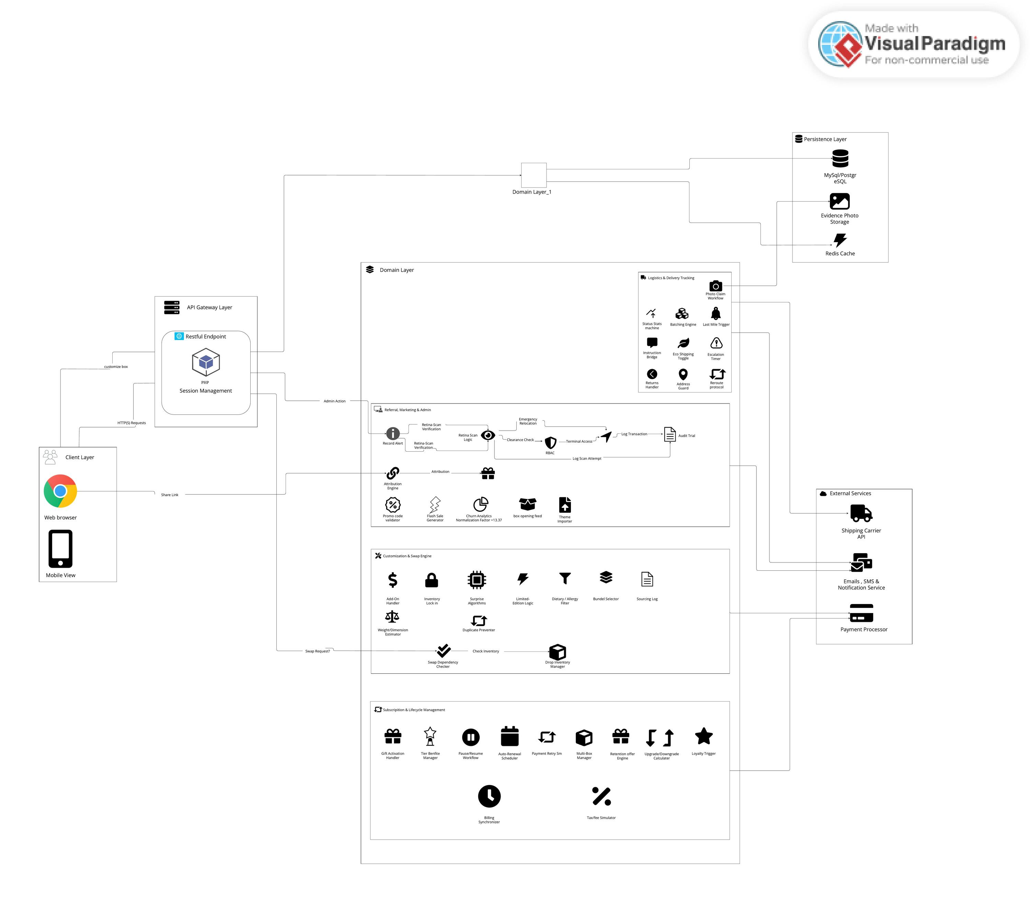
Figure 1: System Architecture Diagram
Layered architecture showing the Client Layer, API Gateway, Domain Layer modules (Subscription & Lifecycle, Customisation & Swap Engine, Logistics & Delivery, Referral & Admin), Persistence Layer, and External Service integrations.

6.2 Use Case Diagram (System Level)
Figure 2 shows the system-level use case diagram with all actors and their interactions across 14 use cases.
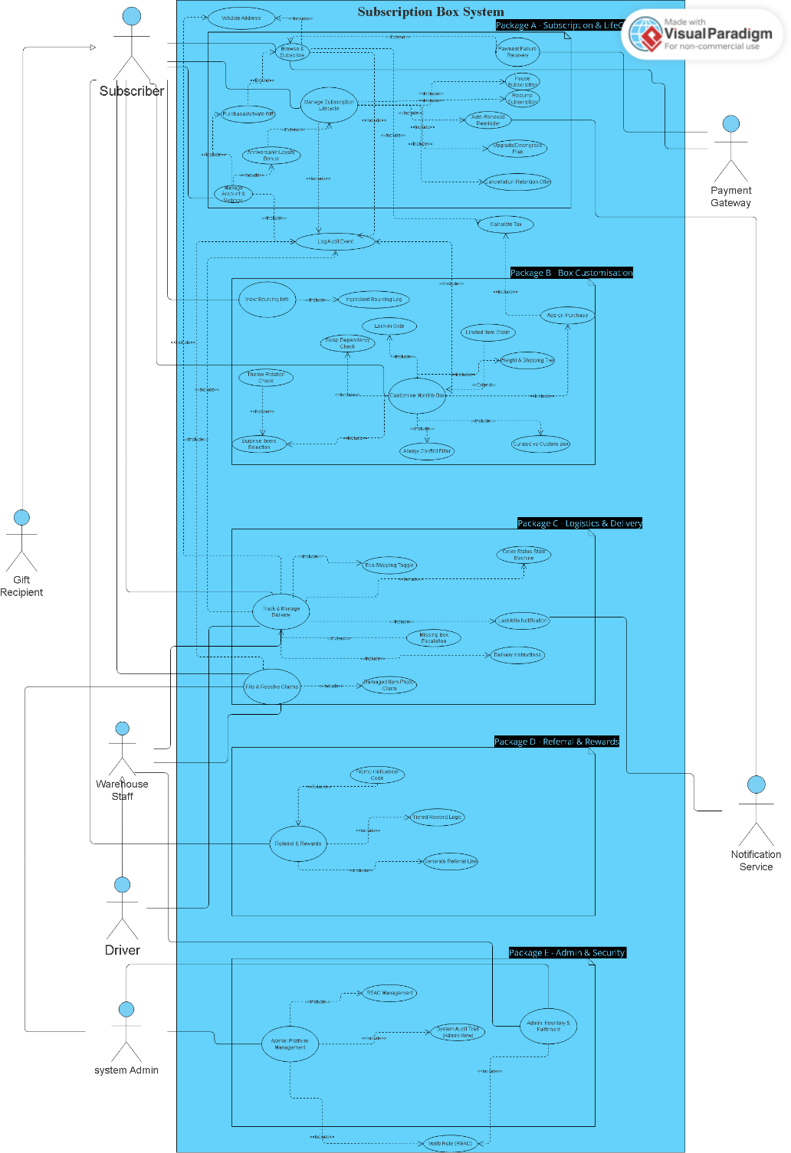
Figure 2: Use Case Diagram (System Level)
System-level use case diagram showing actors (Subscriber, Gift Recipient, Warehouse Staff, Driver, System Admin, Payment Gateway, Notification Service) and 14 use cases with include and extend relationships.

6.3 Activity Diagrams
Figures 3–7 show activity diagrams for key system workflows.
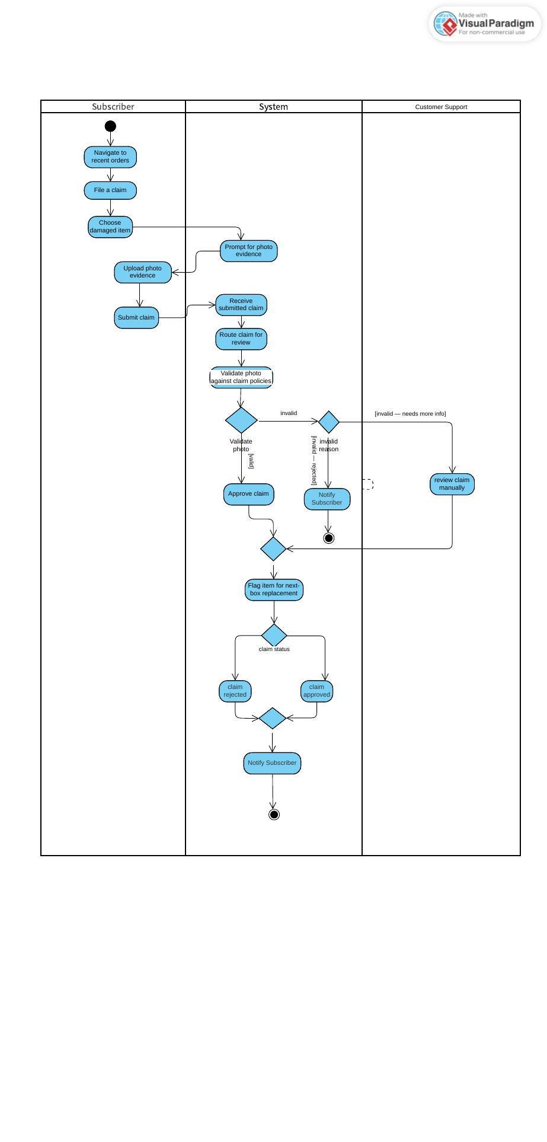
Figure 3: File & Resolve Claims Activity Flow
Swimlane activity diagram showing the claim filing process: Subscriber selects damaged item, uploads photo evidence, system validates the photo against claim policies, Admin reviews and approves or rejects, and the Subscriber is notified of the outcome.
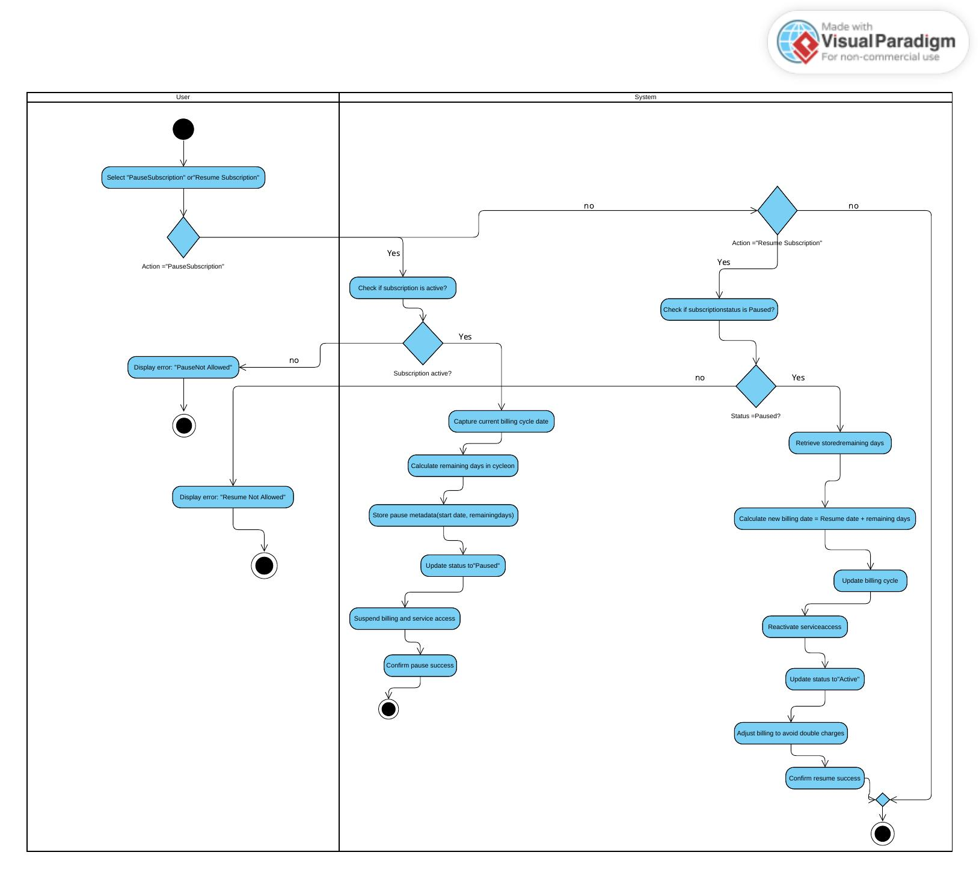
Figure 4: Pause & Resume Subscription Activity Flow
Swimlane activity diagram showing the pause workflow (capturing remaining billing days, updating status to 'Paused', suspending billing) and the resume workflow (recalculating billing date, reactivating service access).
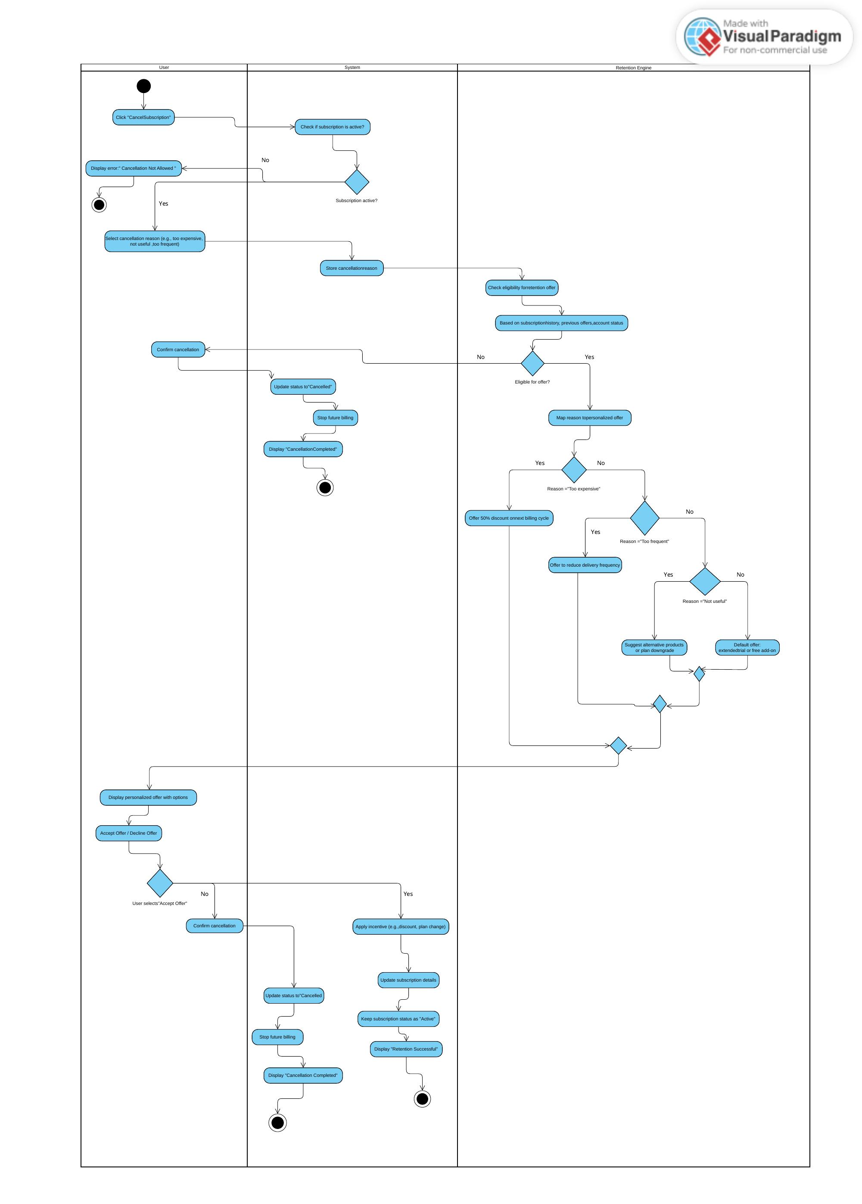
Figure 5: Cancel Subscription with Retention Flow
Swimlane activity diagram showing the cancellation flow with a Retention Engine that maps the subscriber's cancellation reason to a personalised offer (discount, frequency reduction, or plan downgrade) before finalising cancellation.
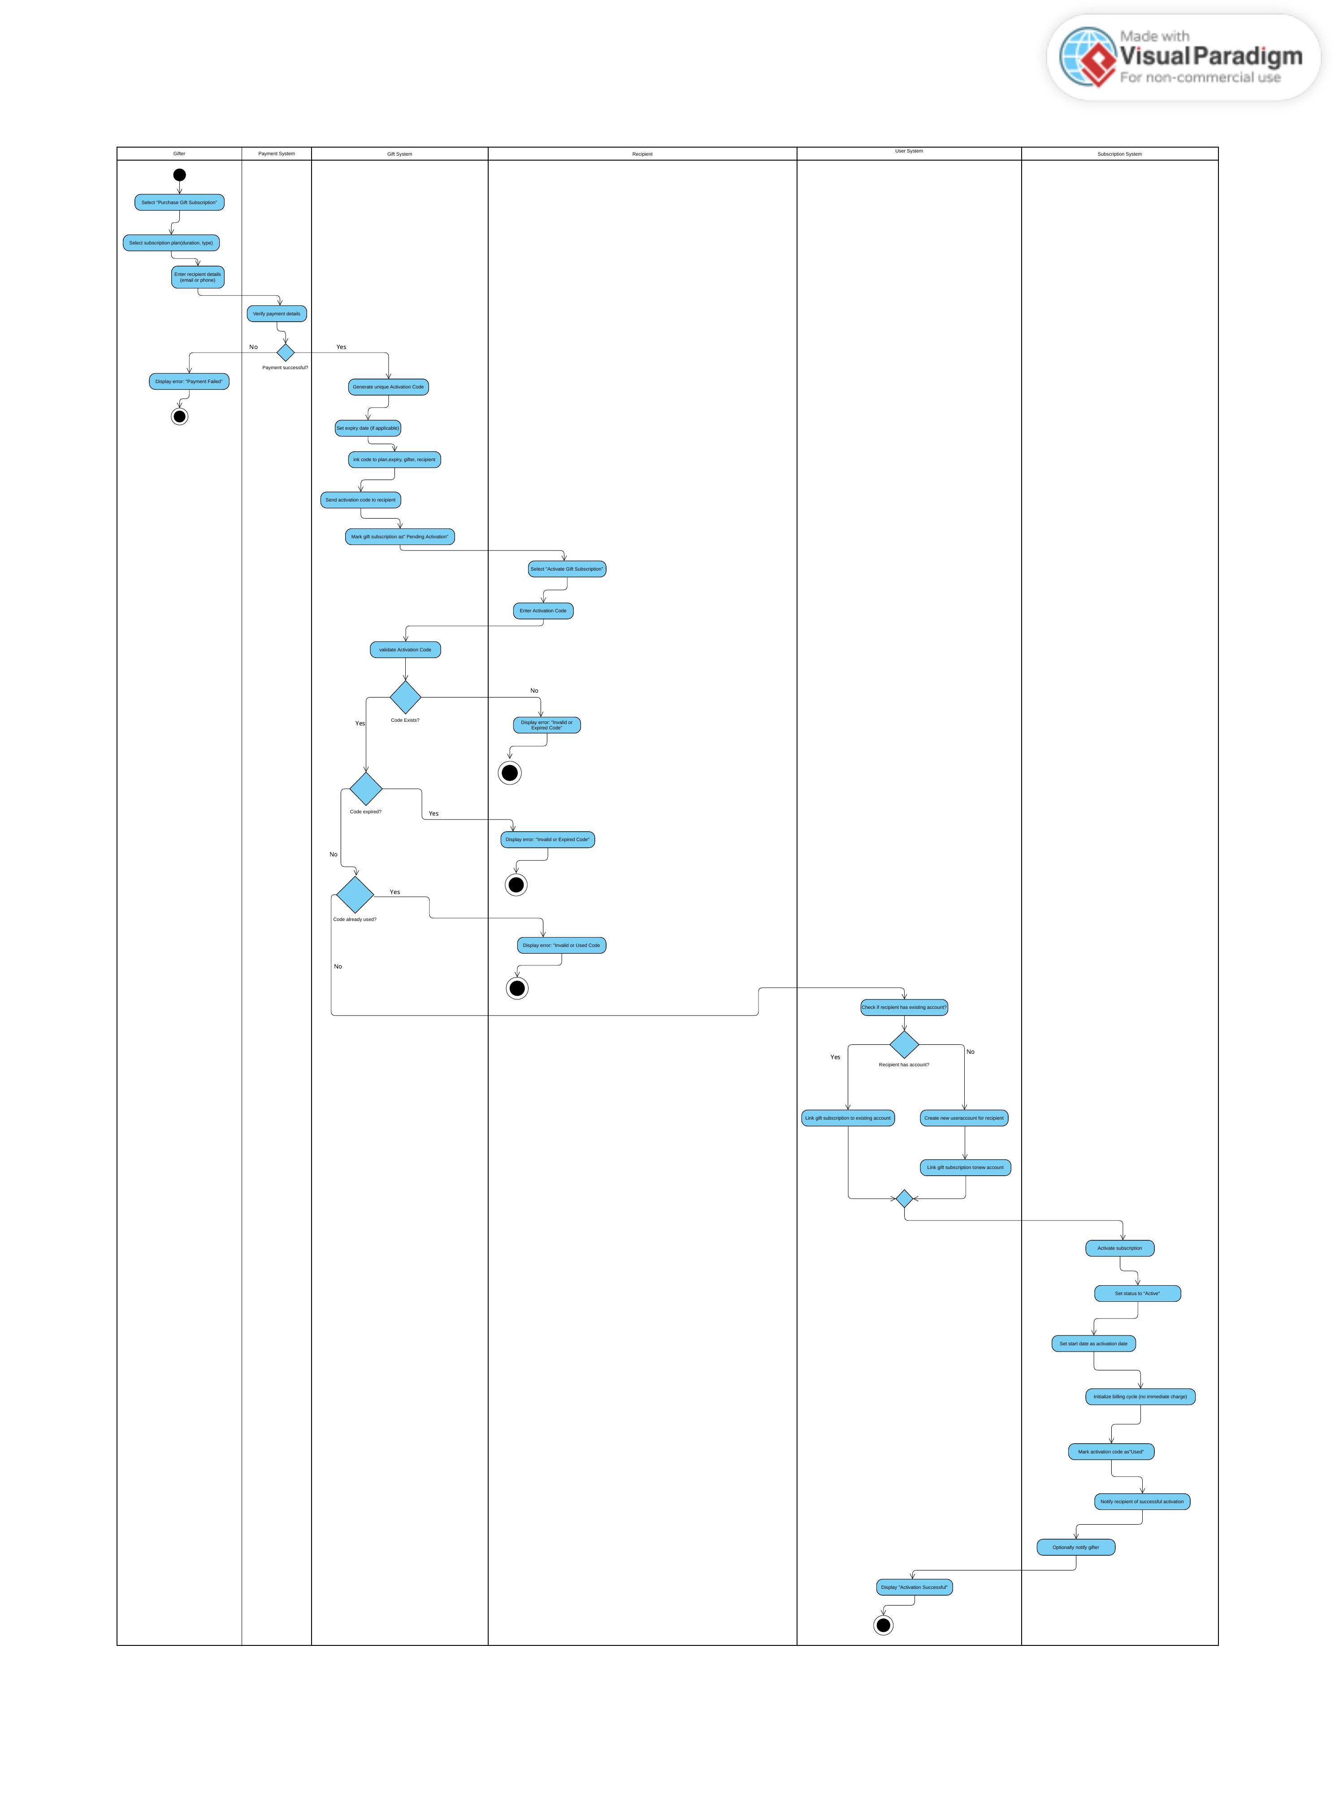
Figure 6: Gift Subscription Purchase & Activation Flow
Swimlane activity diagram spanning six actors (Gifter, Payment System, Gift System, Recipient, User System, Subscription System) showing the full lifecycle from gift purchase through payment, code generation, recipient activation, and subscription initialisation.
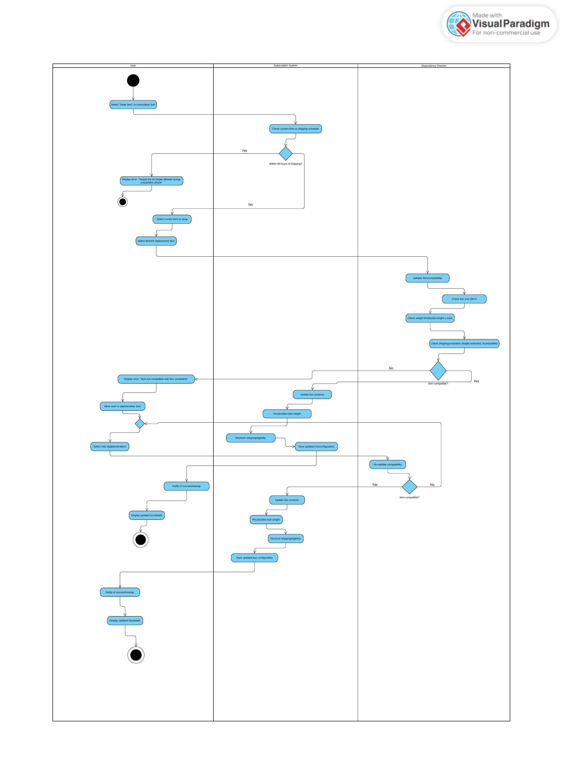
Figure 7: Item Swap with Dependency Checker Flow
Swimlane activity diagram showing the item swap workflow: the system checks the shipping deadline, the Dependency Checker validates weight, size, and shipping constraints, and the box is updated or the swap is rejected.
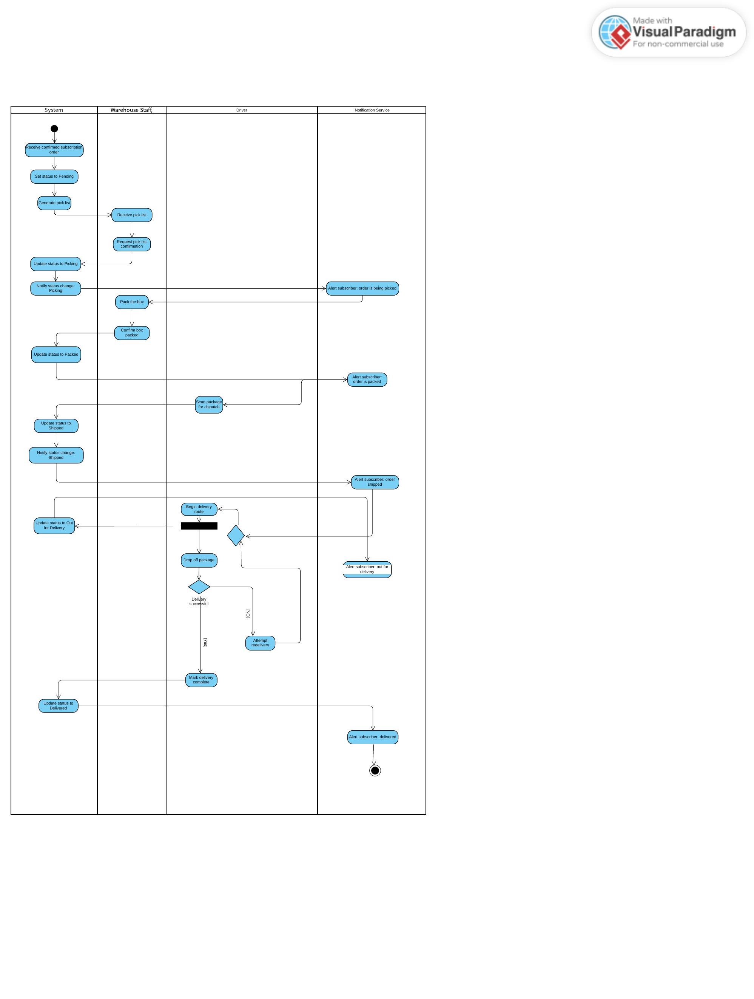
Figure 8: Shipment Fulfilment & Last-Mile Delivery Flow
Swimlane activity diagram across System, Warehouse Staff, Driver, and Notification Service showing the full order lifecycle from pick-list generation through packing, dispatch, last-mile delivery, and subscriber notification at each stage.
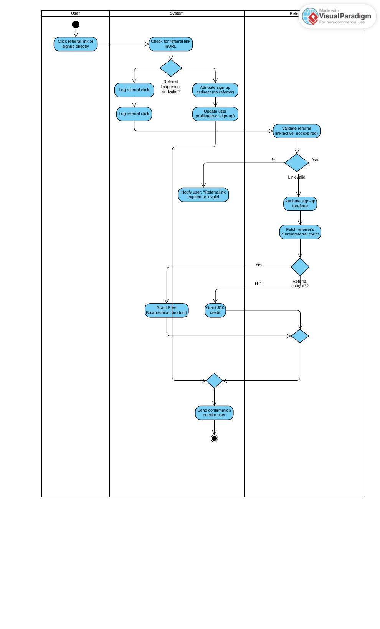
Figure 9: Referral Attribution & Reward Flow
Swimlane activity diagram showing referral link validation, sign-up attribution, referral count evaluation, and tiered reward assignment (\$10 credit for ≤3 referrals, free premium box for >3 referrals).

6.4 Class Diagram
Figure 10 shows the full domain class diagram for Phase 1 of the project, covering all major entities and their relationships.
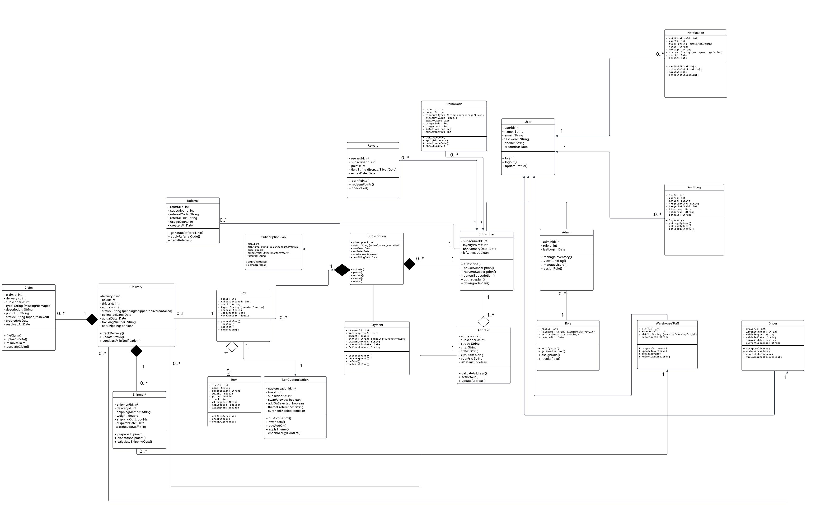
Figure 10: Domain Class Diagram (Phase 1)
Class diagram showing 18 domain entities (User, Subscriber, Admin, Subscription, SubscriptionPlan, Payment, Box, BoxCustomisation, Item, Delivery, Shipment, Driver, WarehouseStaff, Claim, Reward, Referral, Notification, AuditLog, PromoCode, Role, Address) with their attributes, operations, and associations.

6.5 Object Diagrams
The following object diagrams show concrete system states before and after key operations.

Object Diagram — UC-01 Subscribe()
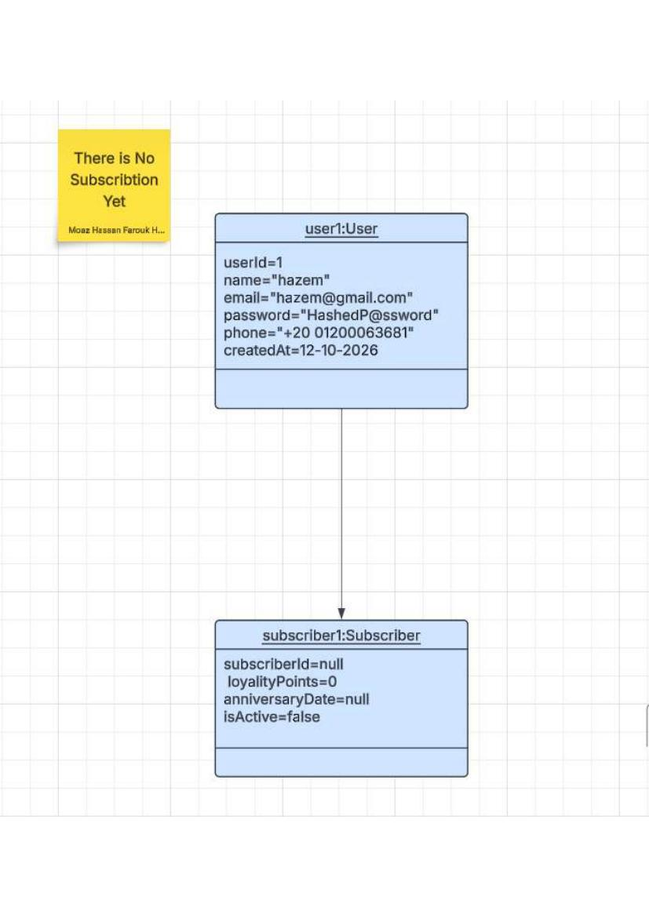
Figure 11: Pre-Condition — UC-01 Subscribe()
Pre: User exists with no active subscription (subscriberId=null, isActive=false).
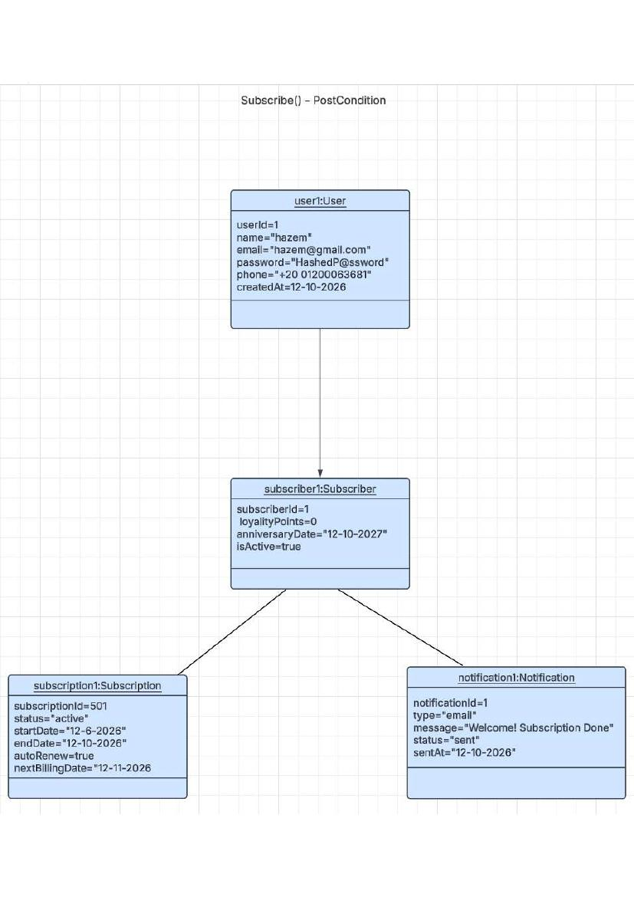
Figure 12: Post-Condition — UC-01 Subscribe()
Post: Subscriber record created (isActive=true), Subscription activated (status='active'), welcome Notification sent.

Object Diagram — UC-02 pauseSubscription()
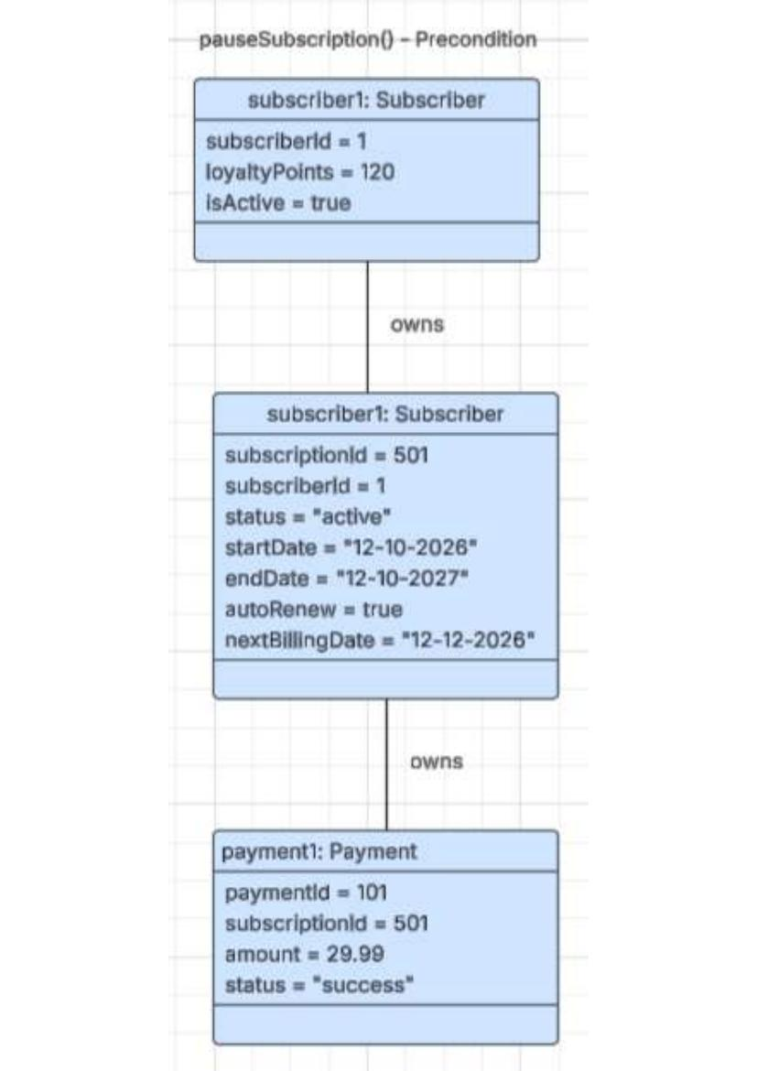
Figure 13: Pre-Condition — UC-02 pauseSubscription()
Pre: Active Subscription (status='active', autoRenew=true, nextBillingDate set) with successful Payment.
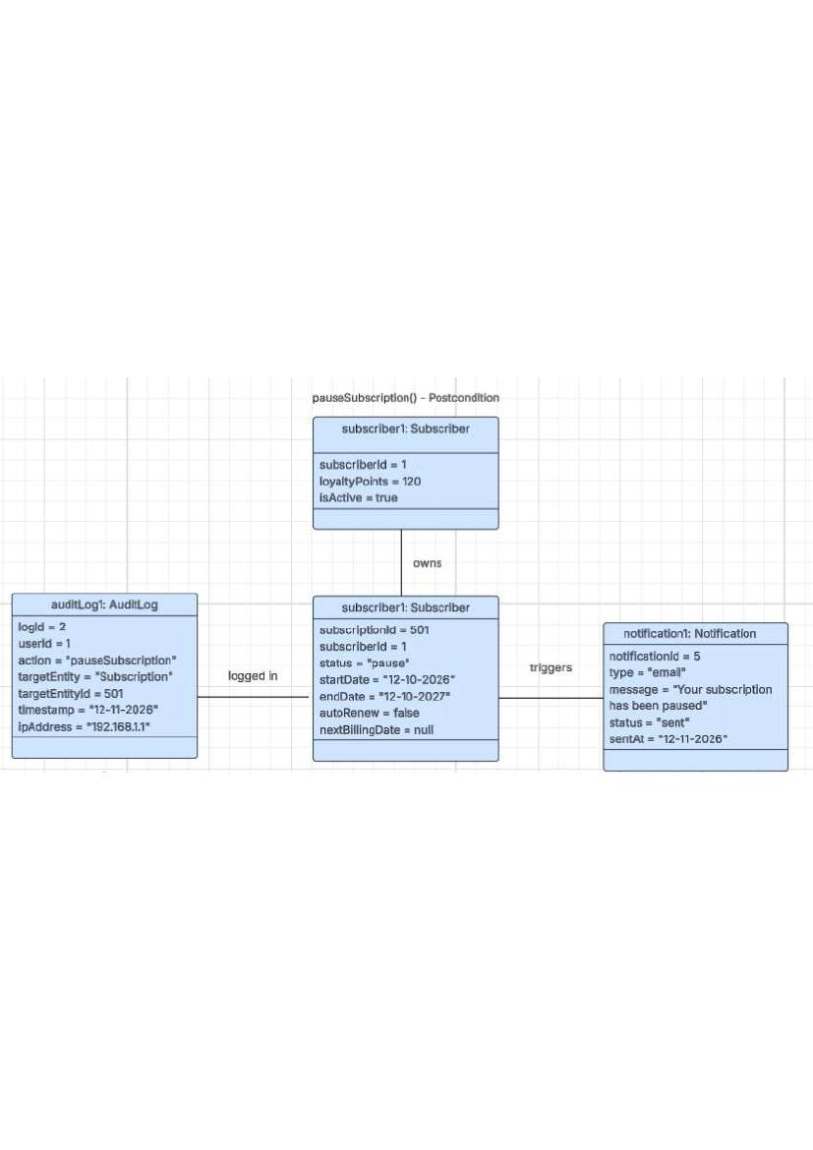
Figure 14: Post-Condition — UC-02 pauseSubscription()
Post: Subscription status set to 'pause', autoRenew=false, nextBillingDate=null; AuditLog recorded; Notification sent.

Object Diagram — UC-03 customiseBox()
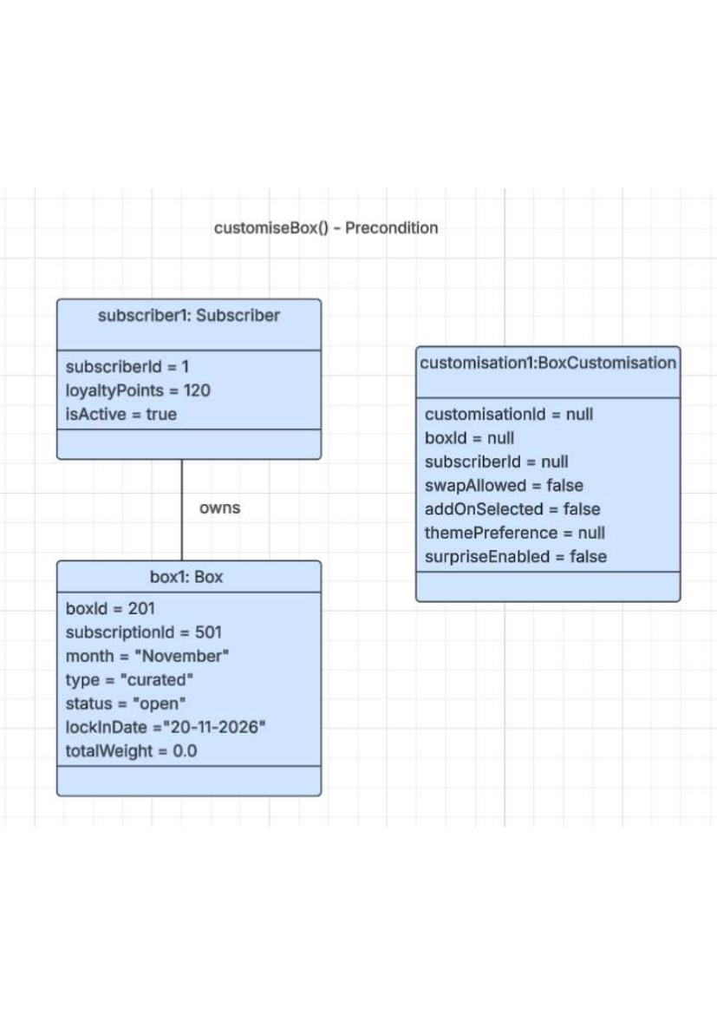
Figure 15: Pre-Condition — UC-03 customiseBox()
Pre: Subscriber owns an open Box; BoxCustomisation record has null fields (no customisation applied yet).
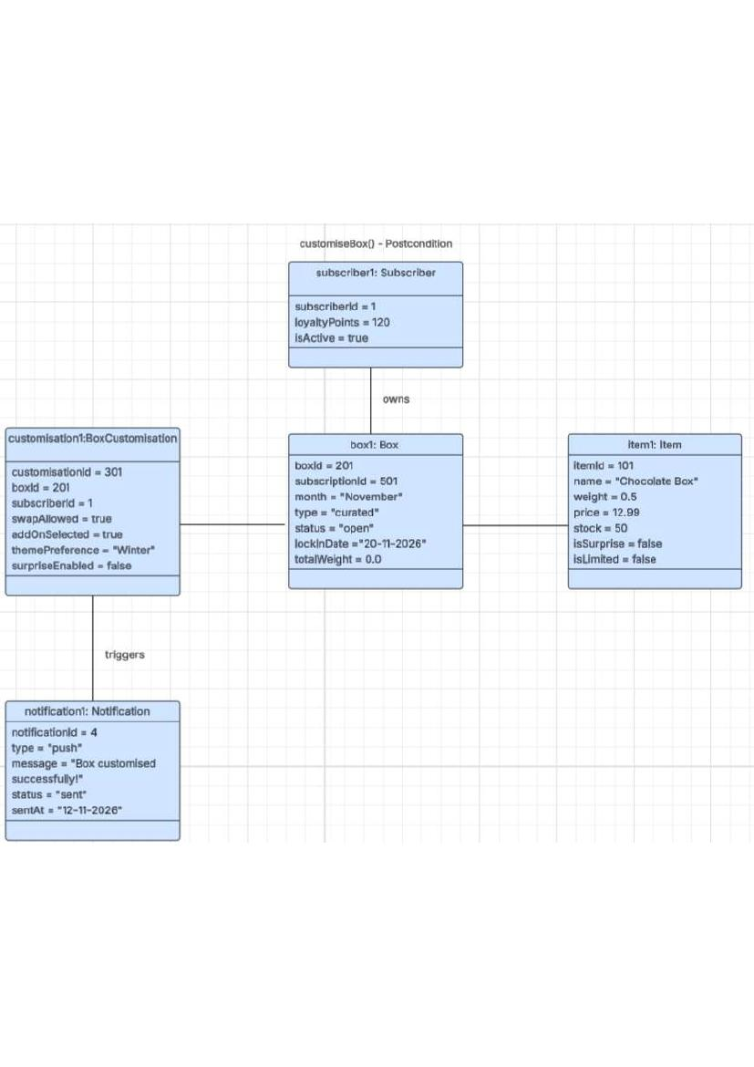
Figure 16: Post-Condition — UC-03 customiseBox()
Post: BoxCustomisation populated (swapAllowed=true, themePreference='Winter'); Item added; Notification sent confirming box customised.

Object Diagram — UC-05 fileClaim()
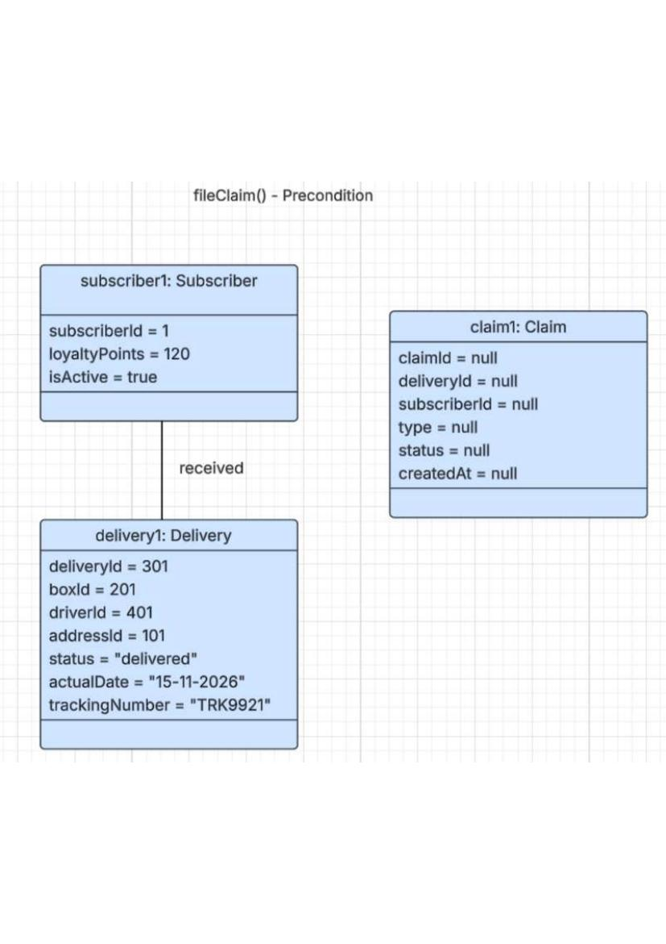
Figure 17: Pre-Condition — UC-05 fileClaim()
Pre: Subscriber has a delivered Delivery; Claim record has all null fields.
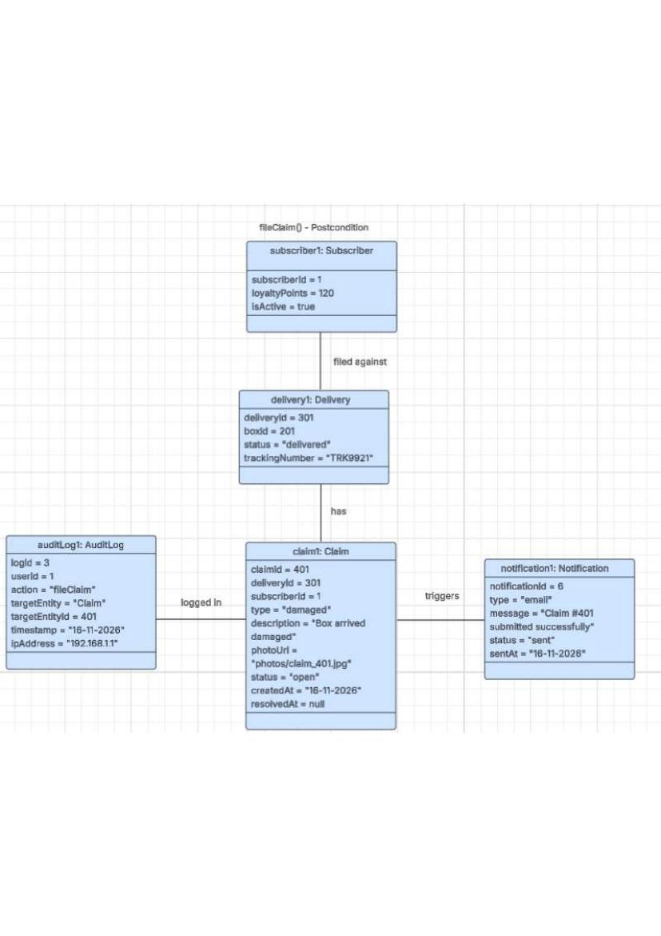
Figure 18: Post-Condition — UC-05 fileClaim()
Post: Claim created (type='damaged', status='open', photoUrl set); AuditLog records the fileClaim action; Notification sent confirming submission.

Object Diagram — UC-08 assignRole()
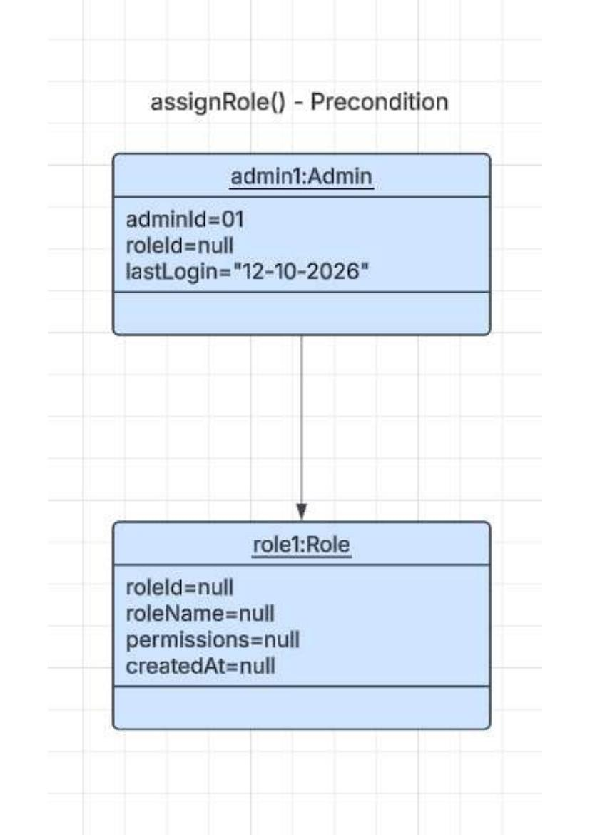
Figure 19: Pre-Condition — UC-08 assignRole()
Pre: Admin exists (roleId=null — no role assigned yet); Role record has null fields.
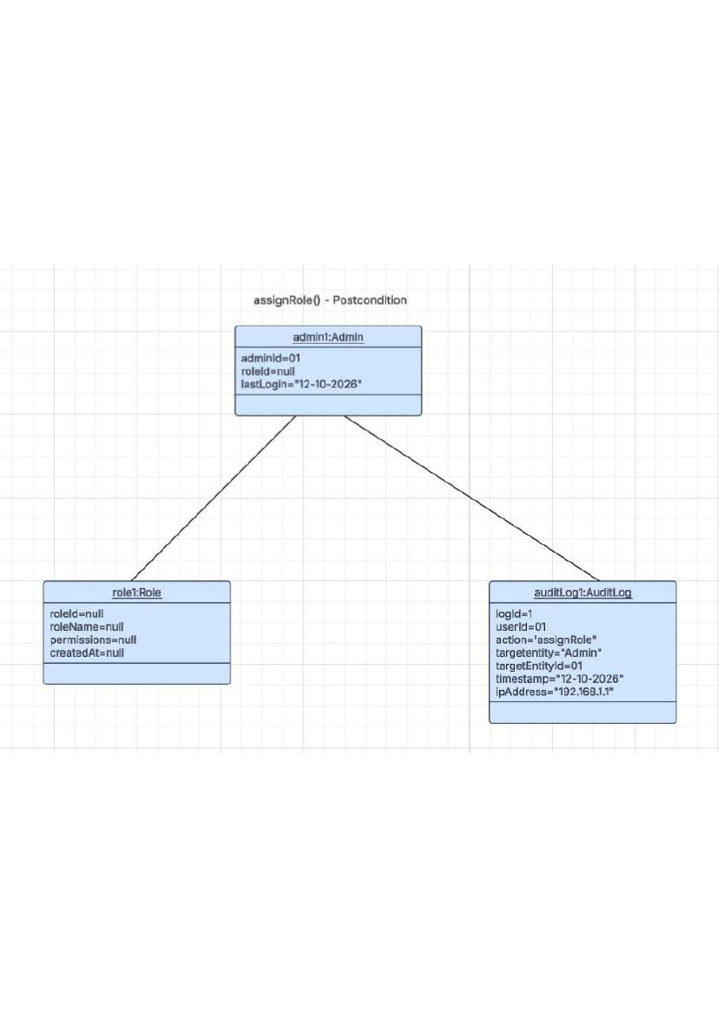
Figure 20: Post-Condition — UC-08 assignRole()
Post: Role assigned to Admin; AuditLog records the assignRole action with timestamp and IP address.

Object Diagram — applyDiscount() — Promo Code
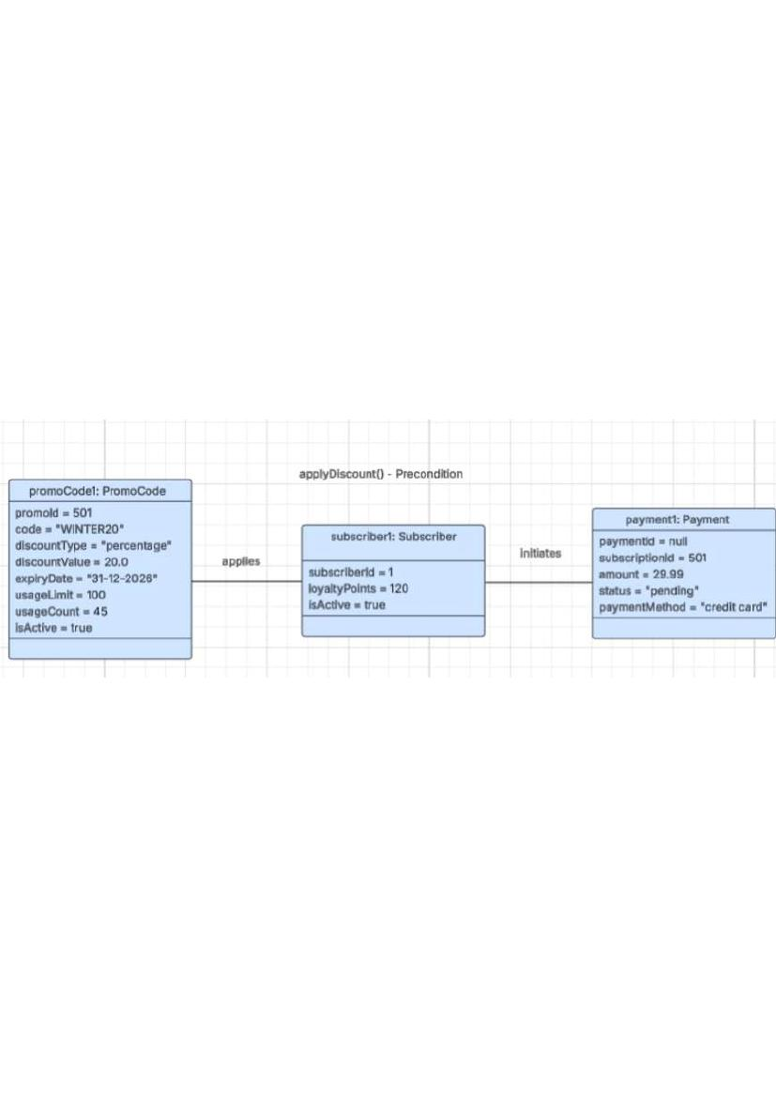
Figure 21: Pre-Condition — applyDiscount() — Promo Code
Pre: PromoCode (WINTER20, 20% off, isActive=true) applied by Subscriber; Payment in 'pending' state.
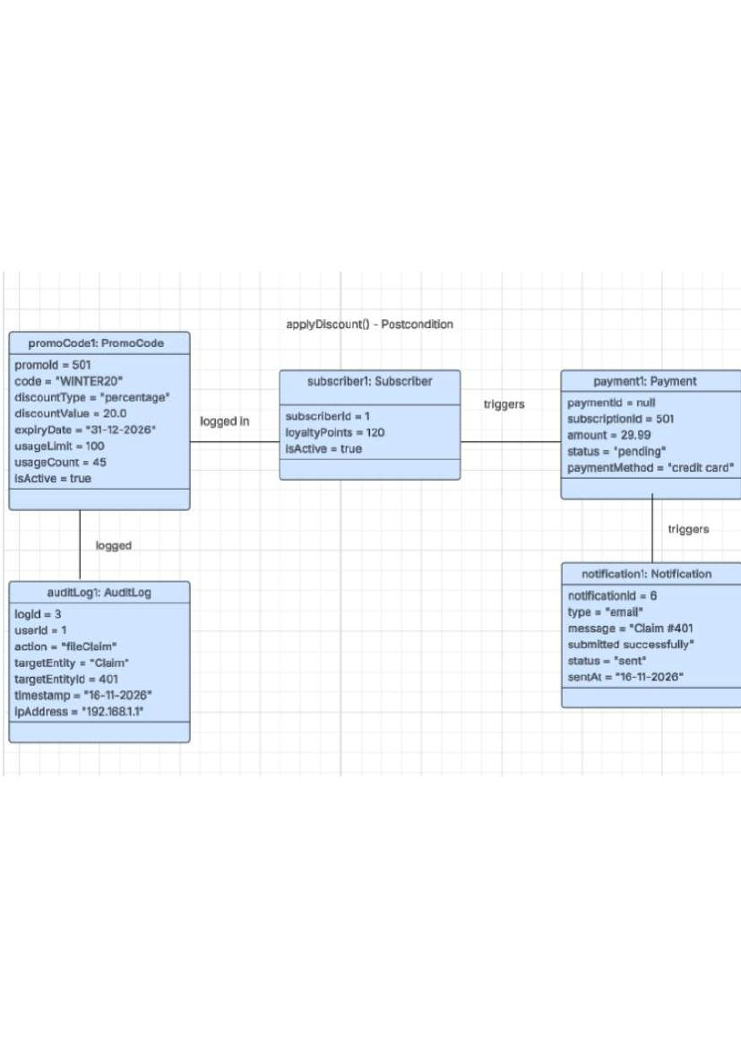
Figure 22: Post-Condition — applyDiscount() — Promo Code
Post: Discount applied; Payment proceeds; AuditLog records fileClaim event; Notification confirms submission.

Object Diagram — trackDelivery()
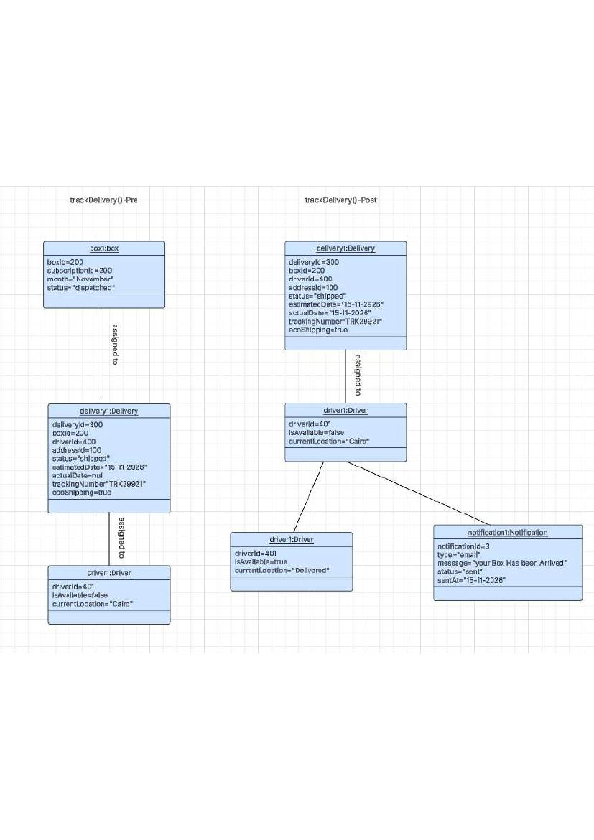
Figure 23: Pre & Post-Condition — trackDelivery()
Pre: Box dispatched (status='shipped'); Delivery record shows 'shipped'; Driver unavailable. Post (on same page): Delivery status='delivered'; Driver marked available with location='Delivered'; Notification sent confirming arrival.

Object Diagram — processPayment()
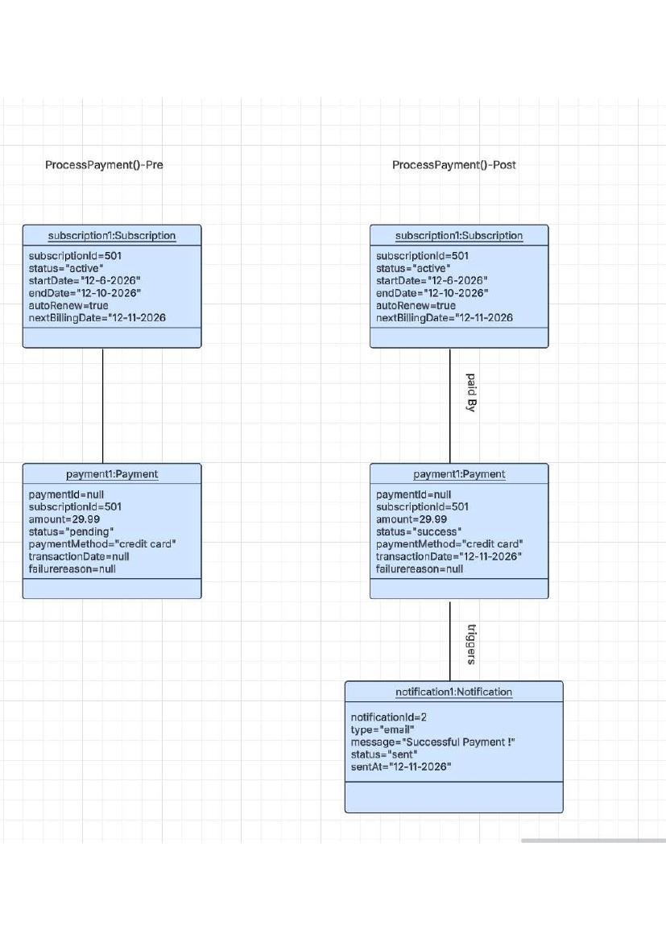
Figure 25: Pre & Post-Condition — processPayment()
Left (Pre): Payment record in 'pending' state (paymentId=null, transactionDate=null). Right (Post): Payment status='success', transactionDate set, Subscription linked via 'paid by' relationship; Notification confirms successful payment.

7. Non-Functional Requirements
Non-functional requirements define the quality attributes and operational constraints that the system must satisfy. These apply system-wide.
ID | Category | Requirement
NFR-01 | Usability | The system shall comply with WCAG 2.1 Level AA accessibility guidelines.
NFR-02 | Usability | All primary subscriber workflows (subscribe, customise box, checkout) shall be completable within 3 user interactions from the home page.
NFR-03 | Usability | The interface shall be fully responsive and functional on desktop (1920×1080), tablet (768px), and mobile (375px) viewports.
NFR-04 | Usability | Error messages shall be descriptive and actionable (e.g., 'Your card was declined — please check the card number and try again').
NFR-05 | Performance | The system shall respond to 95% of user requests within 2 seconds under normal load (up to 500 concurrent users).
NFR-06 | Performance | Page load time (Largest Contentful Paint) shall not exceed 3 seconds on a standard broadband connection.
NFR-07 | Performance | The payment processing workflow shall complete within 5 seconds end-to-end.
NFR-08 | Performance | Database queries for subscription status checks shall execute in under 200 ms.
NFR-09 | Security | All user passwords shall be hashed using bcrypt with a minimum cost factor of 12 before storage.
NFR-10 | Security | All data transmitted between client and server shall be encrypted using TLS 1.2 or higher (HTTPS).
NFR-11 | Security | The system shall implement RBAC with a minimum of four roles: Guest, Subscriber, Warehouse Staff, and Administrator.
NFR-12 | Security | Session tokens shall expire after 30 minutes of inactivity and be invalidated upon logout.
NFR-13 | Security | Payment card data shall not be stored locally; all card storage shall be delegated to a PCI-DSS compliant Payment Gateway.
NFR-14 | Security | The system shall implement protection against OWASP Top 10 vulnerabilities, including SQL Injection, XSS, and CSRF.
NFR-15 | Maintainability | The codebase shall follow a consistent style guide
NFR-16 | Maintainability | Unit test coverage shall be maintained at a minimum of 80% for all business logic layer components.
NFR-17 | Maintainability | All public methods and classes shall include documentation comments (Javadoc or JSDoc).
NFR-18 | Maintainability | The system shall use a modular architecture so that any single module can be updated without impacting unrelated modules.
NFR-19 | Auditability | Every state-changing action (subscription changes, payments, admin operations) shall generate an immutable Audit Log entry including: actor userId, action type, target entity, target entity ID, timestamp, and IP address.
NFR-20 | Data Retention | Audit log entries shall be retained for a minimum of 2 years and shall not be deletable by any user role, including Admin.
NFR-21 | Error Handling | The system shall display a user-friendly error message and log a structured error entry (severity level ERROR) whenever an unhandled exception occurs; no raw stack traces shall be exposed to end users.
NFR-22 | Reliability | The payment retry scheduler (F2) shall be fault-tolerant: if the system restarts during the retry window, all pending retry jobs shall be resumed from the last recorded state within 5 minutes of system restart.

